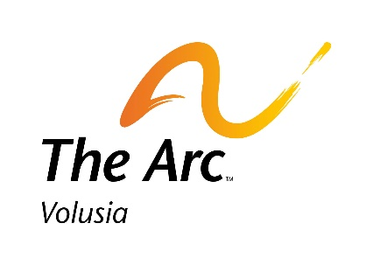
Venetian Bay Golf Club
Saturday, September 10th, 2022 – 8:00am

Registration, 9:00am Shotgun Start

Please Check All That Apply:
______Yes, I/my company will play at $125 per person.
_____ Yes, I/my company will be a Sponsor: Premier Sponsor $5,000
Event Sponsor $3,500
Golf Cart Sponsor $1,500
Beverage Cart Sponsor $900
Corporate Team Sponsor $600

Hole Sponsor $200

TEAM MEMBERS

Please attach an additional page if fielding more than one four-person team
1. | 3.
2. | 4.

Individual/Company Name:_____________________________________________________________
Address:_____________________________________________________________________________

City:________________________________ State:_____________ Zip:__________________________
Contact Name:________________________________________________________________________
Contact Phone:_______________________ Email:__________________________________________
Complete and Return this Form by Mail, Fax, and/or Email
Make Checks Payable to: The Arc of Volusia
Or Visit www.ArcVolusia.Org (to pay registration online)

Mail: The Arc of Volusia, Attn: GOLF

100 Jimmy Huger Circle, Daytona Beach, FL 32117
Contact: Angel Schumaker, Development Coordinator
Phone: 386-274-4736 Fax: 386-274-1222
Email: achievewithus@arcvolusia.org

